Resnick Alumni Tracking System

User manual

David Fiel, theodosios bligiannos, aditi rao, jeremy shaughnessy

VERSION 3

2023

Table of Contents

Introduction 2

User Functions 3

Login 3

Alumni 4

Filter Alumni 5

Alumnus Profile 6

Education 7

Sport 9

Employment History 10

Engagement Survey 11

Notes 13

Create Alumnus 13

Upload Data 15

Alumni Data 15

Graduates 17

Initial Spreadsheet Conversion 18

Validation Tables 20

Add Entry 21

Edit Entry 23

Administrator Functions 25

User Access 25

# Introduction

In the current process, the Coordinator for Leadership and Professional Development has a single extensive spreadsheet to track student athlete alumni after their graduation from Temple University. The Resnick Center refers to these alumni records when reaching out for event planning, mentorships, internships, and more. The problem they currently face is that the spreadsheets are difficult to manage and are updated sporadically due to the inefficiency of the process.

The Resnick Center Alumni Tracking System is an automated solution which will allow the employees at the Resnick Center to upload spreadsheets and be able to manipulate the data through our system. The user will be able to upload the existing alumni tracking spreadsheet to initialize the system and is also able to make uploads of other spreadsheets containing graduate and alumni data, which will be organized into the system. The user is then able to view all Alumni information on the ***Alumni*** page, make edits to existing alumni information, and add new alumni by filling out the ***Create Alumnus*** form. The user is also able to easily filter through the alumni list to locate a specific alumnus to contact them for engagement with the current student athletes.

# User Functions

## Login

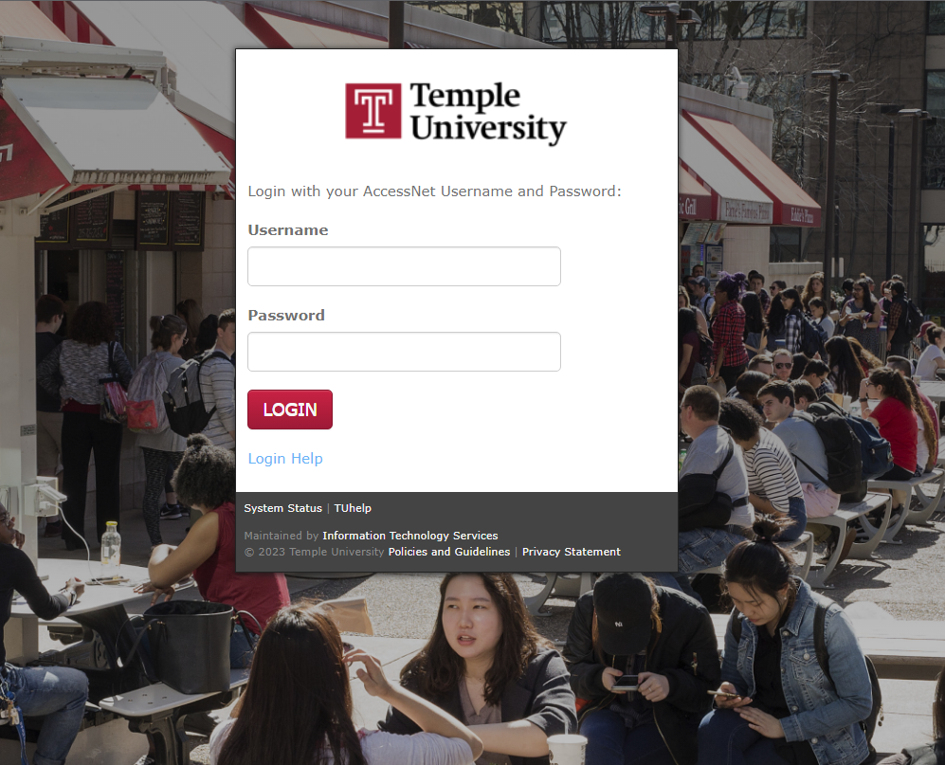

1. Fill out ***Username*** and ***Password*** fields with your Temple AccessNet credentials.
2. Click ***Login***. Upon logging in successfully, the user will be redirected to the Alumni page.

## Alumni

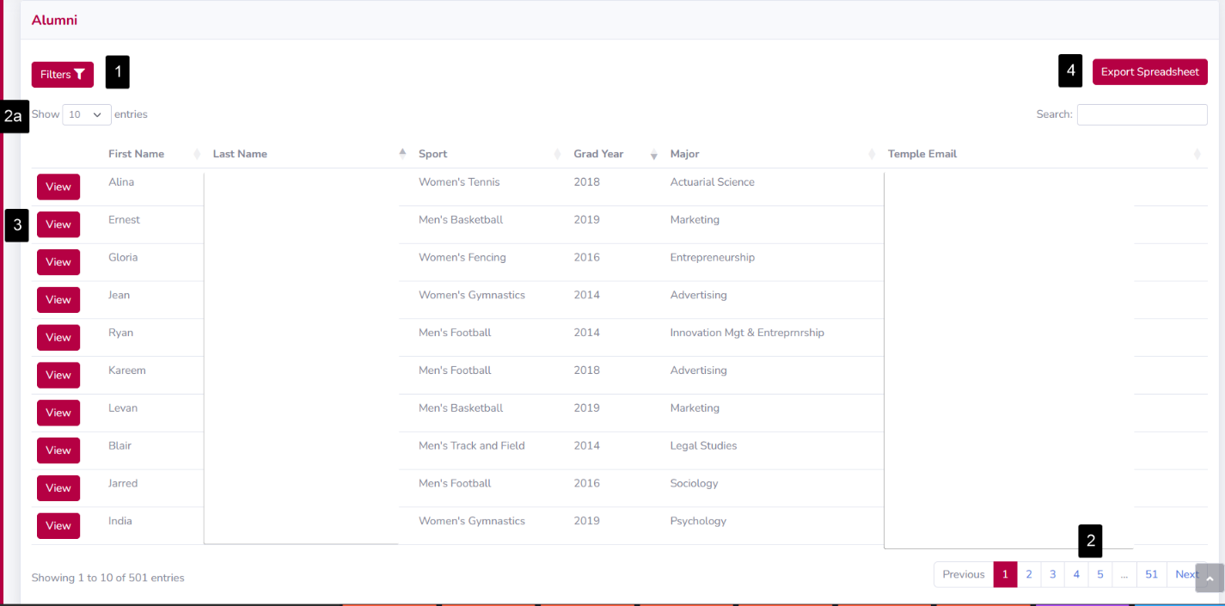

The user will be able to view the list of alumni to locate an alumnus by filtering the list, view an alumnus’ full profile, navigate the pages, or export the list.

1. Click the ***Filters*** button to expand or collapse all options for the user to filter through the data to locate the correct alumnus (see ***Filter Alumni***).
2. The list can be paginated using the numbered buttons in the bottom right of the page, or by using the ***Next*** button.
   1. The number of alumni per page can be changed in the ***Show Entries*** dropdown, with options of 10, 25, 50, or 100 alumni.
3. Click the ***View*** button on an alumnus within the list to view detailed information for that alumnus (See ***Alumnus Profile***).
4. Click the ***Export Spreadsheet*** button to download a spreadsheet containing all the alumni currently in the list.
   1. This spreadsheet respects the applied filters and downloads the relevant alumni.

### Filter Alumni

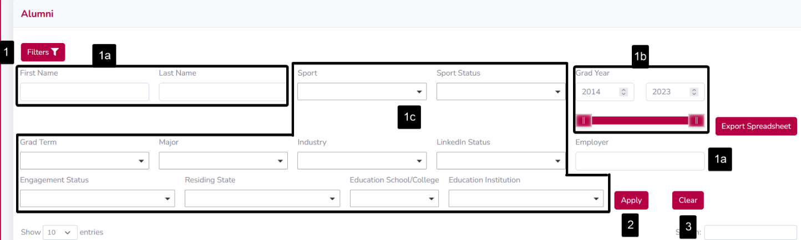

1. Click the ***Filters*** button to reveal the filter dropdown. These filters will update both the alumni list as well as the downloaded spreadsheet.
   1. The following filters are text boxes and allow any entry: ***First Name***, ***Last Name,*** and ***Employer.***
   2. The ***Grad Year*** slider is a range of minimum and maximum graduation year. The value can be adjusted via the draggable indicators, or the text box inputs.
      1. The minimum grad year is determined by the earliest value in the system, and the maximum is set to the current year.
   3. The following filters are dropdowns and accept multiple selections: ***Sport, Sport Status, Grad Term, Major, Industry, LinkedIn Status, Engagement Status, Residing State, Education School/College,*** and ***Education Institution***.
      1. If multiple options are selected, the alumni returned will match *at least one* of the selected options, not all the selected options.
2. Click the ***Apply*** button to update the alumni list with the selected filters.
3. Click the ***Clear*** button to reset all the filters and show the list of all alumni in the system.

### Alumnus Profile

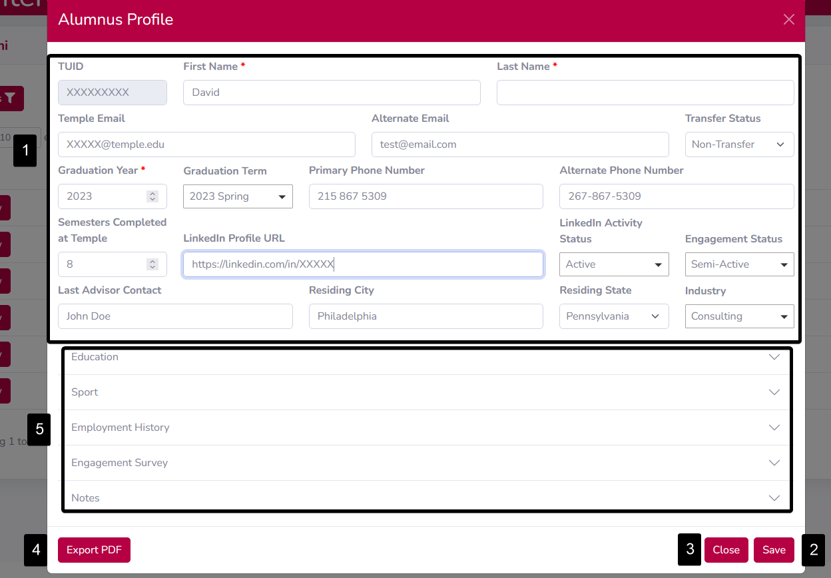

The Alumnus Profile is shown when the user clicks on the ***View*** button in a row of the alumni list.

1. All fields of an Alumnus Profile can be edited except for the ***TUID***.
   1. ***First Name, Last Name,*** and ***Graduation Year*** are required values and must be present before saving.
   2. The remaining fields are optional: ***Email, Alternate Email, Transfer Status, Graduation Year, Graduation Term, Primary Phone Number, Alternate Phone Number, Semesters Completed at Temple, LinkedIn Profile URL, LinkedIn Activity Status, Engagement Status, Last Advisor Contact, Residing City, Residing State,*** and ***Industry.***
2. Click the ***Save*** button after changing values to save the changes to the system. The profile will close.
   1. If any errors occur with saving the changes, a list of errors will appear, and the profile will not close.
3. To close the profile without saving, click the ***Cancel*** button.
4. To download a PDF copy of the Alumnus Profile, click the ***Export PDF*** button.
5. There are five collapsible areas for ***Education, Sport, Employment History, Engagement Survey,*** and ***Notes.*** These sections have their own add, edit, and save buttons, and are not affected by the ***Save*** button at the bottom of the ***Alumnus Profile***.

#### Education

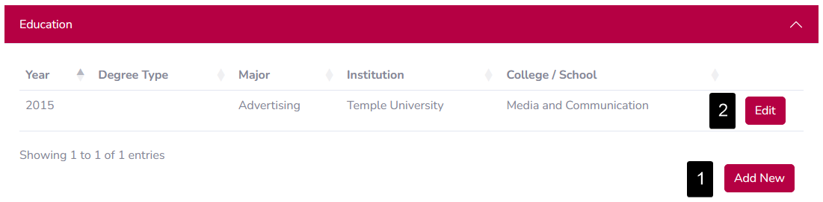

1. To add a new Education record, click the ***Add New*** button. The ***Add Education Record*** area will appear.

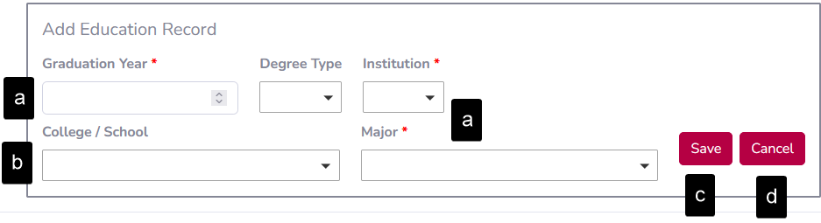

* 1. The ***Graduation Year, Institution,*** and ***Major*** fields are required and must be filled in before saving.
  2. The ***College / School*** field is dependent on the ***Institution*** field. It will be blank until an Institution is selected.
  3. After filling in values, click the ***Save*** button. The ***Add Education Record*** area will close, and the new record will be added to the table.
     1. If there is an error with the input data, a list of errors will appear, and the area will not close.
  4. To close without saving, click the ***Cancel*** button.

1. To edit an existing Education record, click the ***Edit*** button in the associated row. The ***Edit Education Record*** area will appear, and the values from that row will be populated.

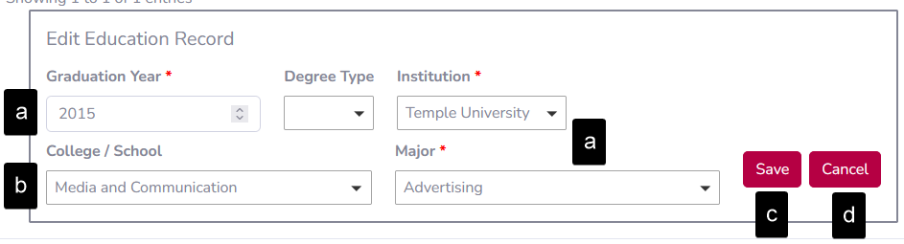

* 1. The ***Graduation Year, Institution,*** and ***Major*** fields are required and must be filled in before saving.
  2. The ***College / School*** field is dependent on the ***Institution*** field. It will be cleared if the selected Institution changes.
  3. After filling in values, click the ***Save*** button. The ***Edit Education Record*** area will close, and the record will be updated in the table.
     1. If there is an error with the inputted data, a list of errors will appear, and the area will not close.
  4. To close without saving, click the ***Cancel*** button.

#### Sport

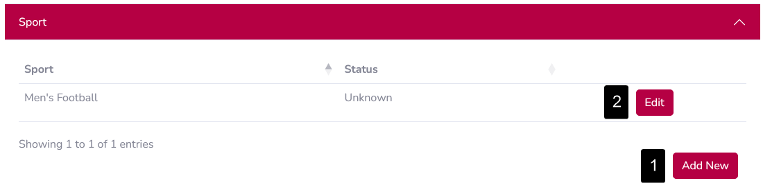

1. To add a new Sport record, click the ***Add New*** button. The ***Add Sport Record*** area will appear.

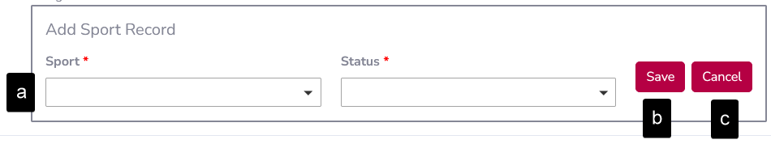

* 1. ***Sport*** and ***Sport Status*** are both required fields and must be filled in before saving.
  2. After filling in values, click the ***Save*** button. The ***Add Sport Record*** area will close, and the new record will be added to the table.
     1. If there is an error with the input data, a list of errors will appear, and the area will not close.
  3. To close without saving, click the ***Cancel*** button.

1. To edit an existing Sport record, click the ***Edit*** button in the associated row. The ***Edit Sport Record*** area will appear, and the values from that row will be populated.

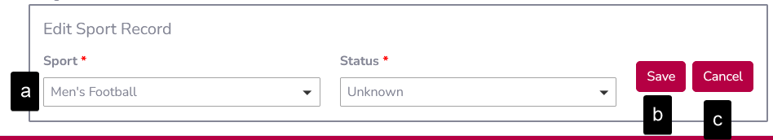

* 1. ***Sport*** and ***Sport Status*** are both required fields and must be filled in before saving.
  2. After filling in values, click the ***Save*** button. The ***Edit Sport Record*** area will close, and the record will be updated in the table.
     1. If there is an error with the input data, a list of errors will appear, and the area will not close.
  3. To close without saving, click the ***Cancel*** button.

#### Employment History

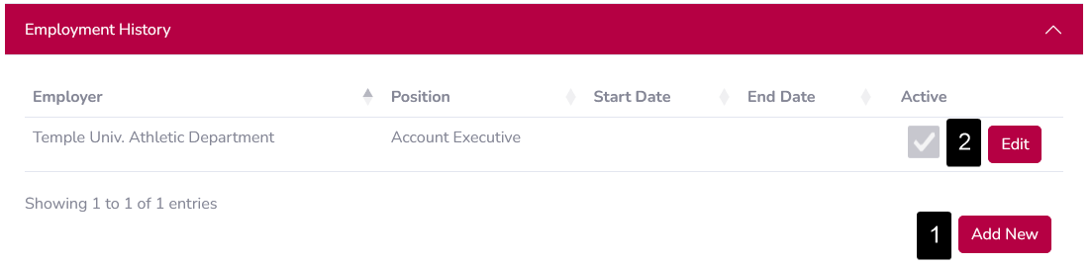

1. To add a new Employment record, click the ***Add New*** button. The ***Add Employment Record*** area will appear.

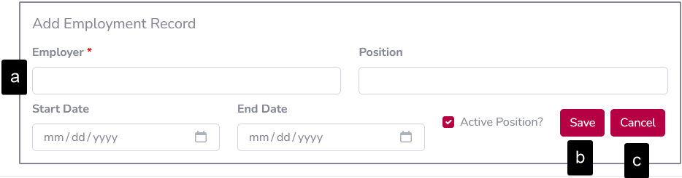

* 1. ***Employer*** is the only required field and must be filled in before saving.
  2. After filling in values, click the ***Save*** button. The ***Add Employment Record*** area will close, and the new record will be added to the table.
     1. If there is an error with the inputted data, a list of errors will appear, and the area will not close.
  3. To close without saving, click the ***Cancel*** button.

1. To edit an existing Employment record, click the ***Edit*** button in the associated row. The ***Edit Employment Record*** area will appear, and the values from that row will be populated.

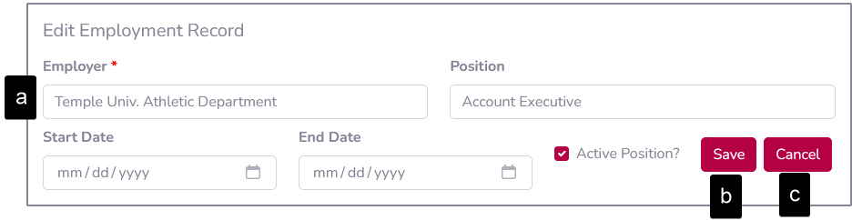

* 1. ***Employer*** is the only required field and must be filled in before saving.
  2. After filling in values, click the ***Save*** button. The ***Edit Employment Record*** area will close, and the record will be updated in the table.
     1. If there is an error with the input data, a list of errors will appear, and the area will not close.
  3. To close without saving, click the ***Cancel*** button.

#### Engagement Survey

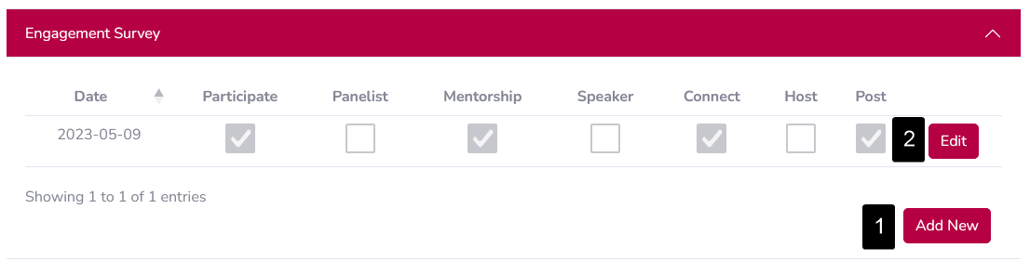

1. To add a new Engagement Survey record, click the ***Add New*** button. The ***Add Engagement Survey Record*** area will appear.

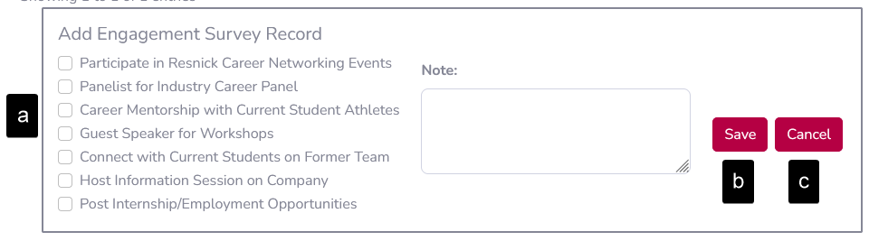

* 1. No fields are required before submission.
  2. After filling in values, click the ***Save*** button. The ***Add Engagement Survey Record*** area will close, and the new record will be added to the table.
  3. To close without saving, click the ***Cancel*** button.

1. To edit an Engagement Survey record, click the ***Edit*** button in the associated row. The ***Edit Engagement Survey Record*** area will appear, and the values from that row will be populated.

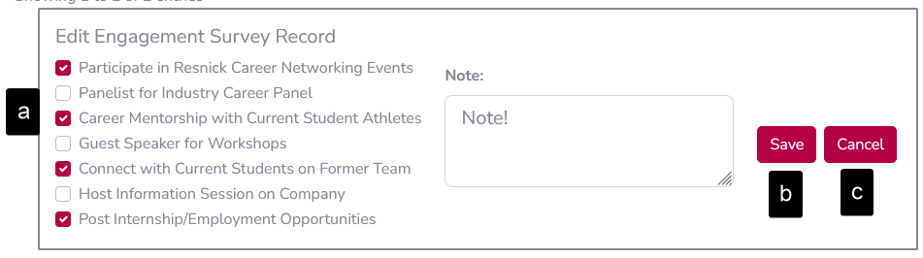

* 1. No fields are required before submission.
  2. After filling in values, click the ***Save*** button. The ***Edit Engagement Survey Record*** area will close, and the record will be updated in the table.
  3. To close without saving, click the ***Cancel*** button.

#### Notes

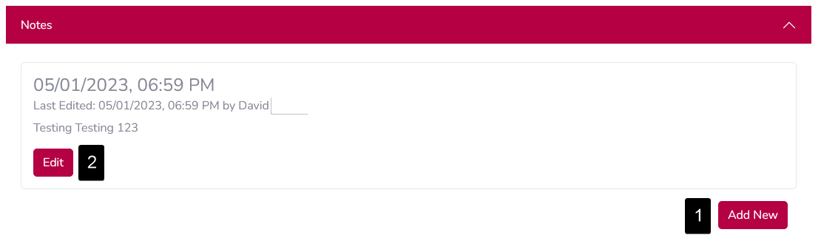

1. To add a new Note, click the ***Add New*** button. The ***Add Note*** area will appear.

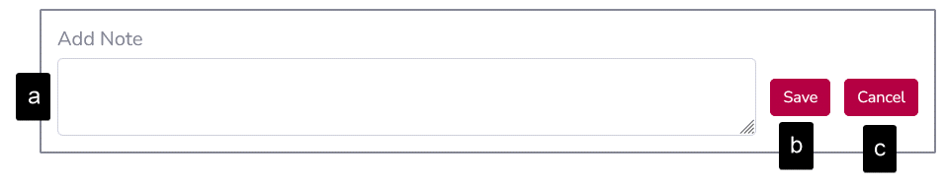

* 1. The text area is a required field and must be filled in before saving.
  2. After filling in the note, click the ***Save*** button. The ***Add Note*** area will close, and the new note will be added to the profile.
  3. To close without saving, click the ***Cancel*** button.

1. To edit an existing Note, click the ***Edit*** button in the associated note card. The ***Edit Note*** area will appear, and the note text will be populated.

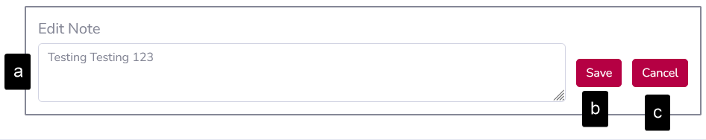

* 1. The text area is a required field and must be filled in before saving.
  2. After filling in the note, click the ***Save*** button. The ***Edit Note*** area will close, and the note card will be updated.
  3. To close without saving, click the ***Cancel*** button.

## Create Alumnus

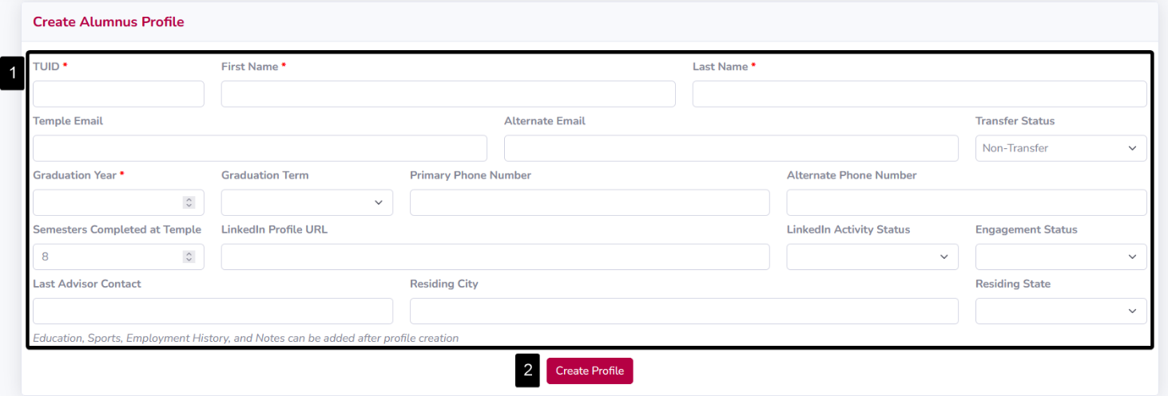

1. Fill out this form with new alumnus information.
   1. ***TUID, First Name, Last Name,*** and ***Graduation Year*** are all required fields, which must be filled in for the form to submit successfully.
   2. The following fields are text boxes and allow the user to type an entry: ***TUID, First Name***, ***Last Name, Temple Email, Alternate Email, Graduation Year, Primary Phone Number, Alternate Phone Number, Semesters Completed at Temple, LinkedIn Profile URL, Last Advisor Contact,*** and ***Residing City.***
   3. The following fields are dropdowns with multiple options to select from: ***Transfer Status, Graduation Term, LinkedIn Activity Status, Engagement Status,*** and ***Residing State.***
   4. If an input is invalid, or if a duplicate entry is made, an error message will appear at the bottom of the screen displaying a bulleted list of all errors.
2. Click the ***Create Profile*** button. If there are no errors, the new alumnus entry will be added to the system and appear in the ***Alumni*** page.

## Upload Data

### Alumni Data

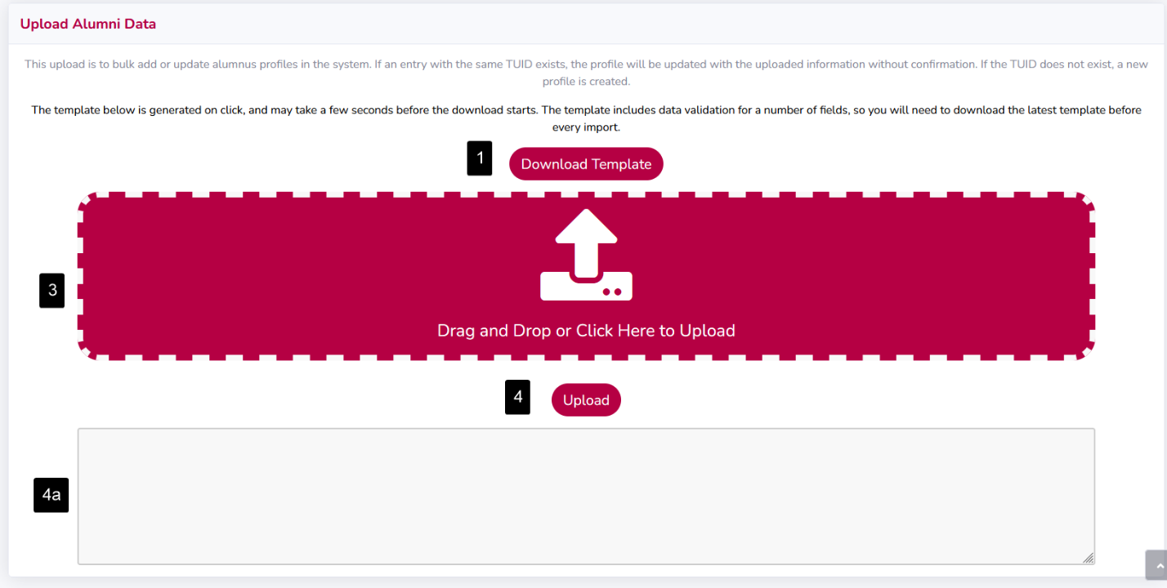

1. Download the Alumni Data template using the ***Download Template*** button.
   1. The template may take a few seconds to begin downloading. Do not repeatedly click the button, as this will cause the file to be downloaded multiple times and slow down processing times.
2. Fill out the spreadsheet with alumni information.
   1. Alumni records are matched on TUID, so existing records will be updated, or new records will be created. The exception is the note column: if this column is filled, a new note will be added to the Alumnus record.
   2. Sport records are matched on TUID and Sport, so existing records will be updated, or new records will be created.
   3. Education, Employment, and Engagement Survey records will only add new records, not update existing ones. Existing records can be updated using the ***Alumnus Profile*** interface.
      1. If an Education record exists with identical TUID, Major, Degree, and Institution, the import will fail for the new record.
3. Drag & drop the filled template into the upload area, marked with a dashed white line. Alternatively, you may click within the box to open the file selector window. The file name of the selected file will be shown in the upload area, confirm this is the correct file.
4. Click the ***Upload*** button to begin the upload process.
   1. The area below the Upload button is a live status of the import process.
      1. When the upload is completed successfully, the number of imported records is shown.

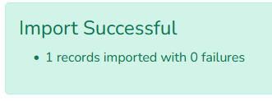

* + 1. When the upload encounters errors, the number of failures as well as a list of errors is shown. Click the ***Download Failed Rows*** button to download the failed rows for further processing.

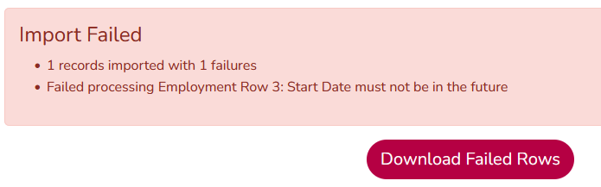

### Graduates

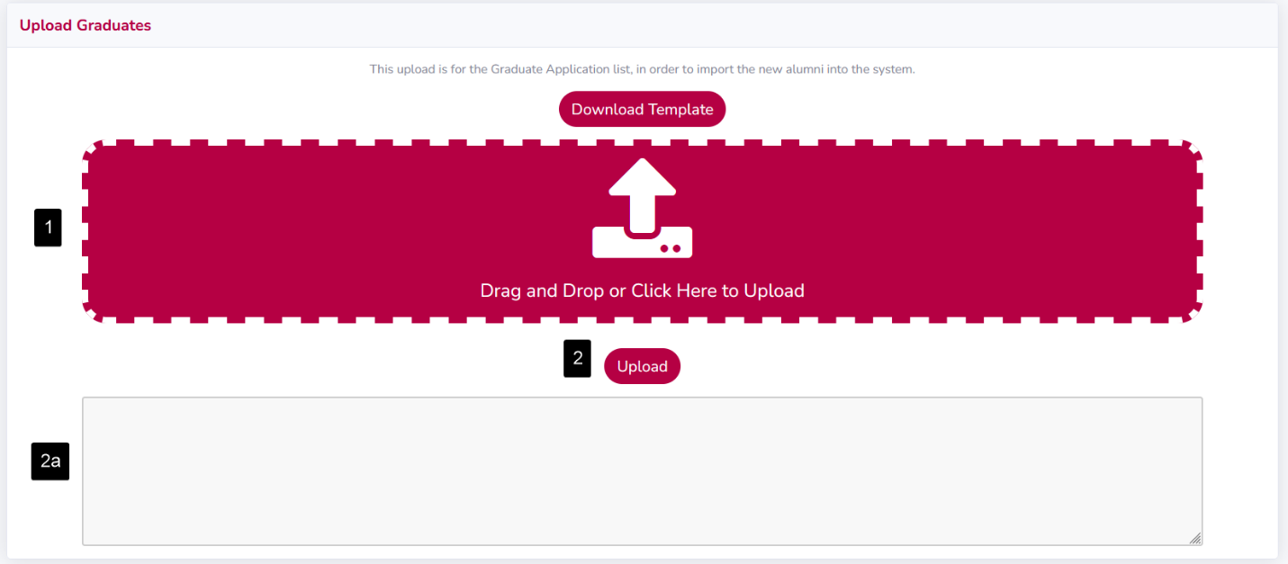

This upload is designed to use the Graduate Application report from Banner as its input. A template is provided for reference; however, you should be able to upload the report from Banner without modification.

1. Drag & drop the Graduate Application report into the upload area, marked with a dashed white line. Alternatively, you may click within the box to open the file selector window. The file name of the selected file will be shown in the upload area, confirm this is the correct file.
2. Click the ***Upload*** button to begin the upload process.
   1. The area below the Upload button is a live status of the import process.
      1. When the upload is completed successfully, the number of imported records is shown.

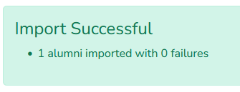

* + 1. When the upload encounters errors, the number of failures as well as a list of errors is shown. Click the ***Download Failed Rows*** button to download the failed rows for further processing.

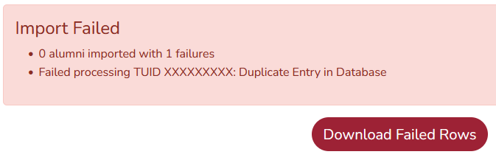

### Initial Spreadsheet Conversion

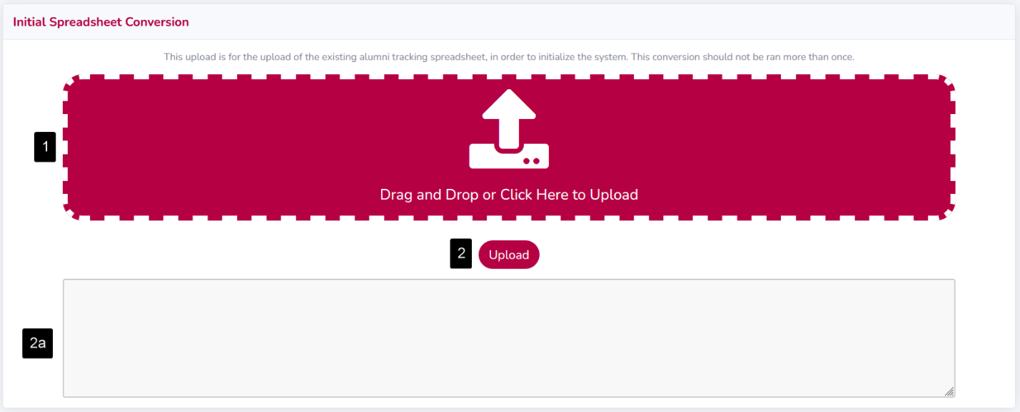

This upload is designed to use the original “Athletic Alumni – Sheet” that was provided at the beginning of Capstone 1. The only modification this sheet needs is in the Sport column: Sport **codes** should be used, not sport **names**, and multiple sport codes must be **comma separated** (e.g. “MCC, MTO”).

1. Drag & drop the filled template into the upload area, marked with a dashed white line. Alternatively, you may click within the box to open the file selector window. The file name of the selected file will be shown in the upload area, confirm this is the correct file.
2. Click the ***Upload*** button to begin the upload process.
   1. The area below the Upload button is a live status of the import process.
      1. When the upload is completed successfully, the number of imported records is shown.



* + 1. When the upload encounters errors, the number of failures as well as a list of errors is shown. Click the ***Download Failed Rows*** button to download the failed rows for further processing.



## Validation Tables

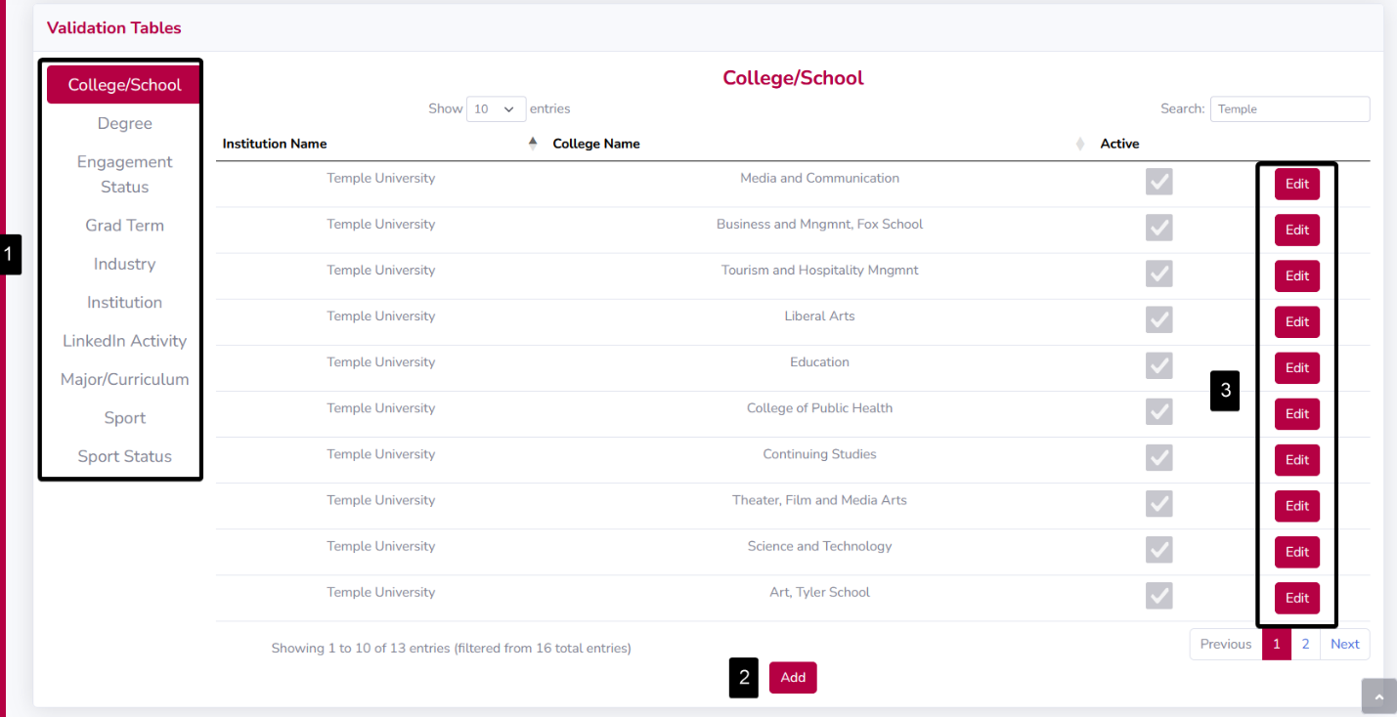

Validation tables contain the entries that are considered valid for a given data point. Any updates to the entries in a validation table will influence the options in dropdown menus, the ***View Alumnus*** interface, and the Alumni Data upload.

1. Click one of the following validation tables to view its entries: ***College/School, Degree, Engagement Status, Grad Term, Industry, Institution, LinkedIn Activity, Major/Curriculum, Sport,*** and ***Sport Status***.
2. Click the ***Add*** button to add a new record to a validation table.
3. Click the ***Edit*** button to edit existing records in the validation table.

### Add Entry

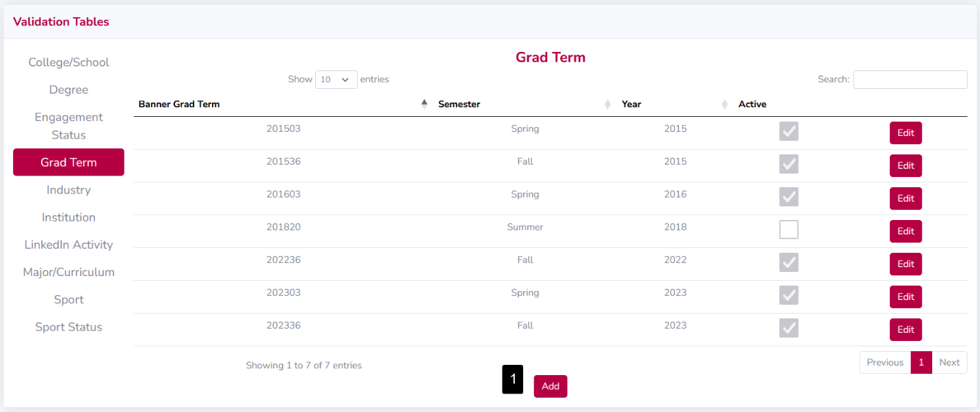

We will use the ***Grad Term*** validation table to demonstrate how to add an entry to a validation table, however this process is nearly identical for all other validation tables.

1. Click the ***Add*** button and the ***Add Grad Term*** window appears.

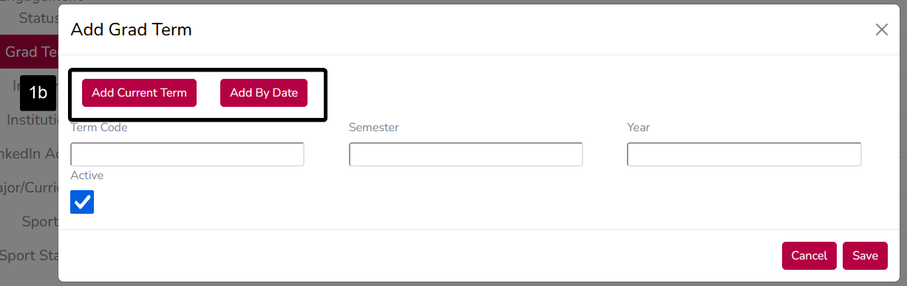

* 1. For validation table entries, all fields are required. Fill out all available fields, which change based on the currently selected table.
  2. For Grad Term only, there are the ***Add Current Term*** and ***Add By Date*** buttons. ***Add Current Term*** will fill in the fields with the information from the current term as returned by Banner. ***Add By Date*** will open a date picker to pick the active term on that date as returned by Banner.

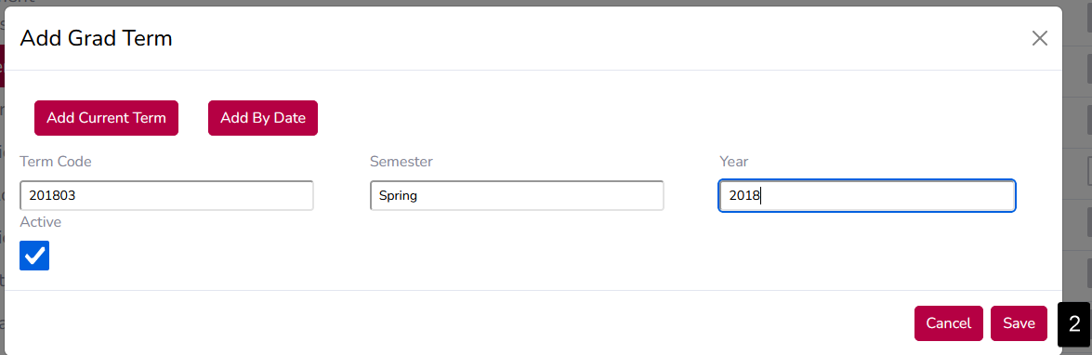

1. Click the ***Save*** button. If there are any errors with your values, they will be displayed. If there are no errors, the ***Add Grad Term*** window will close, and you can see the new entry in the table.

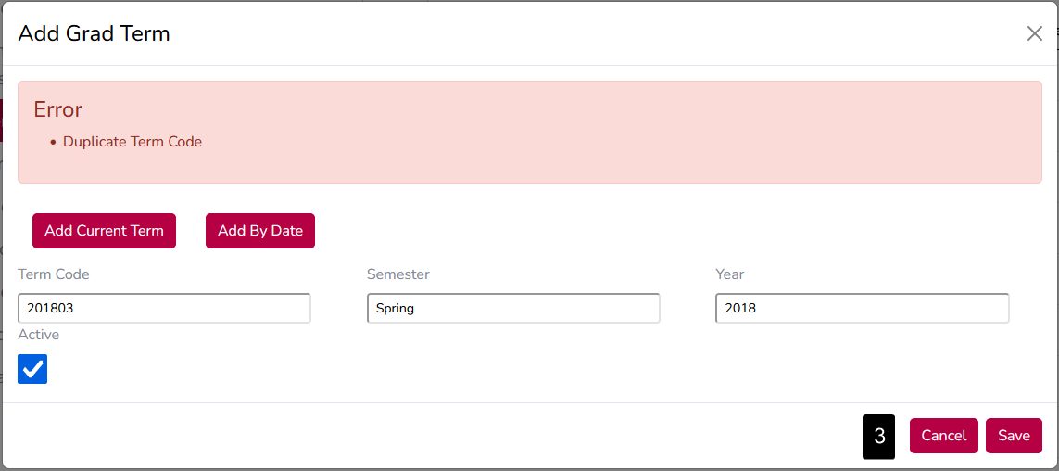

1. To cancel and discard your changes, click the ***Cancel*** button.

Edit Entry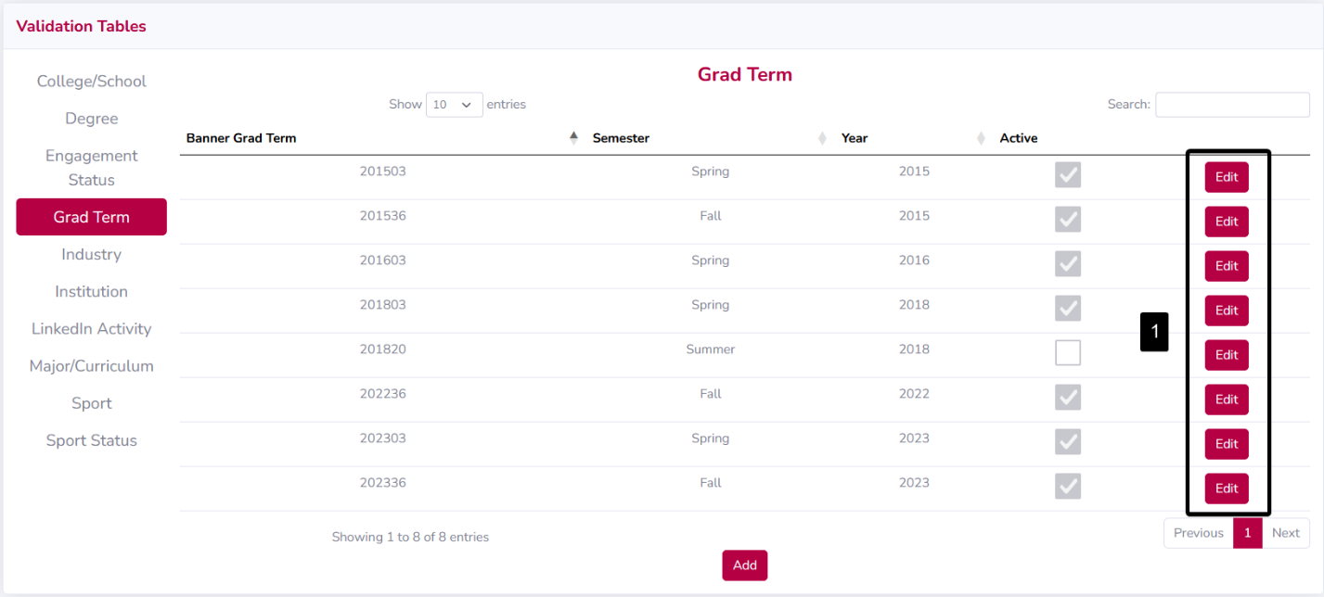

We will use the ***Grad Term*** validation table to demonstrate how to edit an entry in a validation table, but this process is almost identical for all other validation tables.

1. Identify the row you would like to edit and click the corresponding ***Edit*** button, and the **Edit Grad Term** window appears.

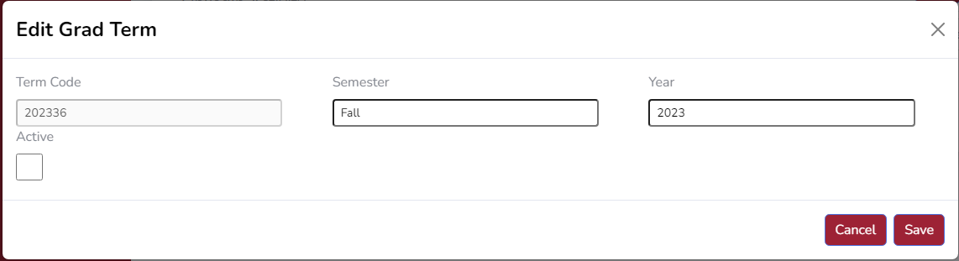

* 1. The fields are prefilled with the existing values from the table. Edit these as you see fit.

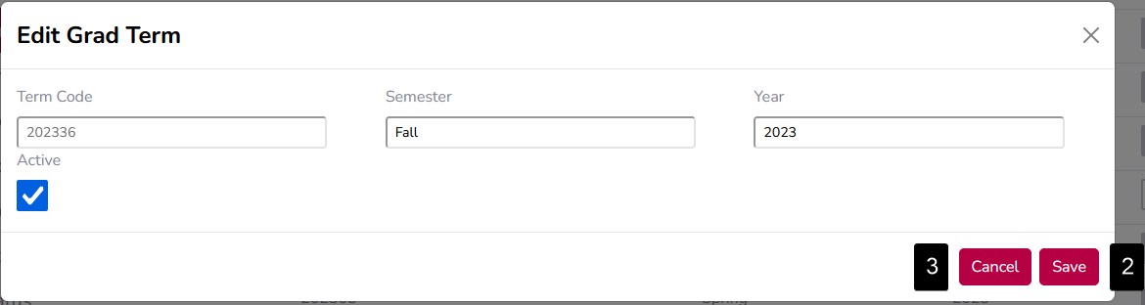

1. Click the ***Save*** button. If there are any errors with your values, they will be displayed. If there are no errors, the **Edit Grad Term** window will close, and you can see your updated data in the table.
2. To cancel and discard your changes, click the ***Cancel*** button.

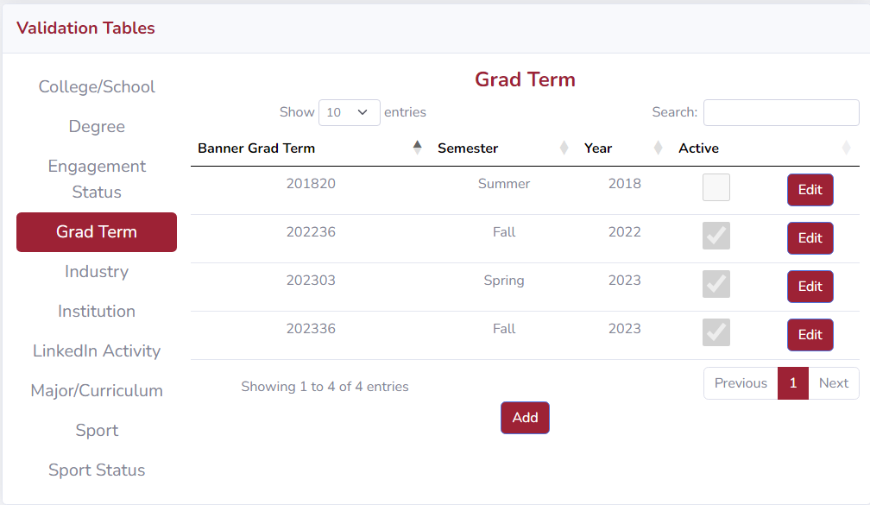

# Administrator Functions

## User Access

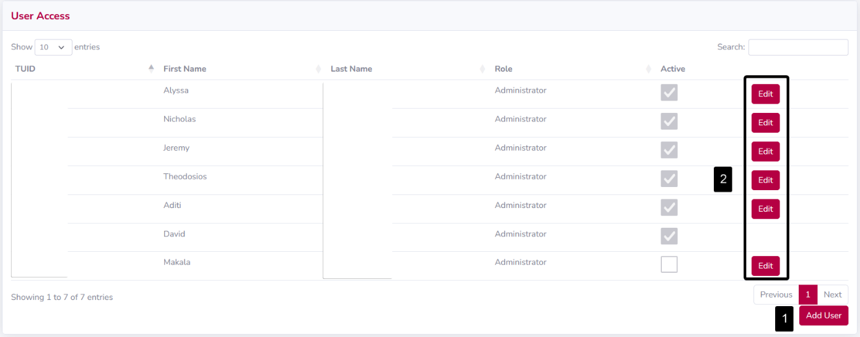

The User Access page shows a list of all users with current and prior access to the system. On this page, an administrator can add new users, edit existing users’ privileges, and deactivate users. An administrator cannot edit their own user account.

1. Click on the ***Add User*** button to add a new user.
   1. Enter the ***TUID*** of the individual to be added. If the TUID is valid, the new user’s name will be populated into the ***First Name*** and ***Last Name*** fields.
   2. Select the desired role type from the ***Role Type*** dropdown menu.
   3. Select their active status by checking the ***Active User*** checkbox.
      1. An inactive user is unable to use the system.

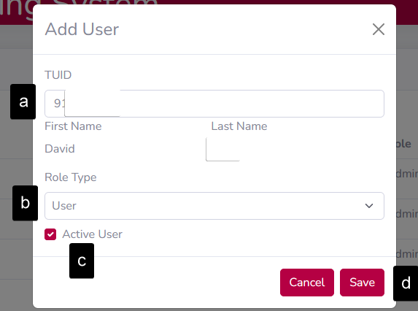

* 1. Click the ***Save*** button to add the user to the system. If an error occurs, the details will be shown, and the user will not be added until all errors are resolved.

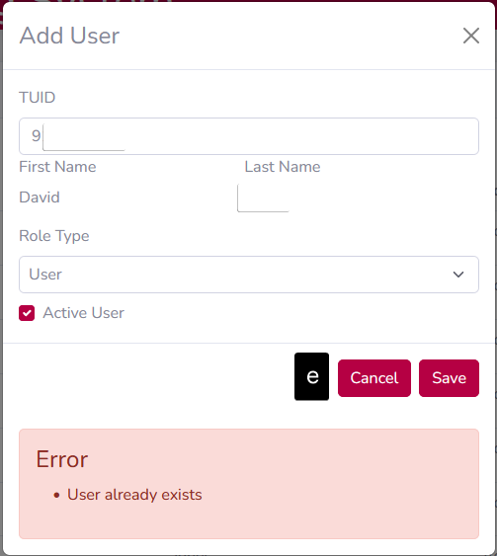

* 1. To cancel and discard your changes, click the ***Cancel*** button.

1. Click on the ***Edit*** button in a user’s row to edit their role type or active status.
   1. Select the desired role type from the ***Role Type*** dropdown menu.
   2. Select their active status by checking the ***Active User*** checkbox.
      1. An inactive user is unable to use the system.

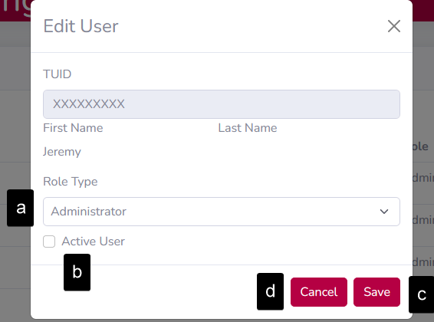

* 1. Click the ***Save*** button to update the user’s information.
  2. To cancel and discard your changes, click the ***Cancel*** button.